Shubham Bisht
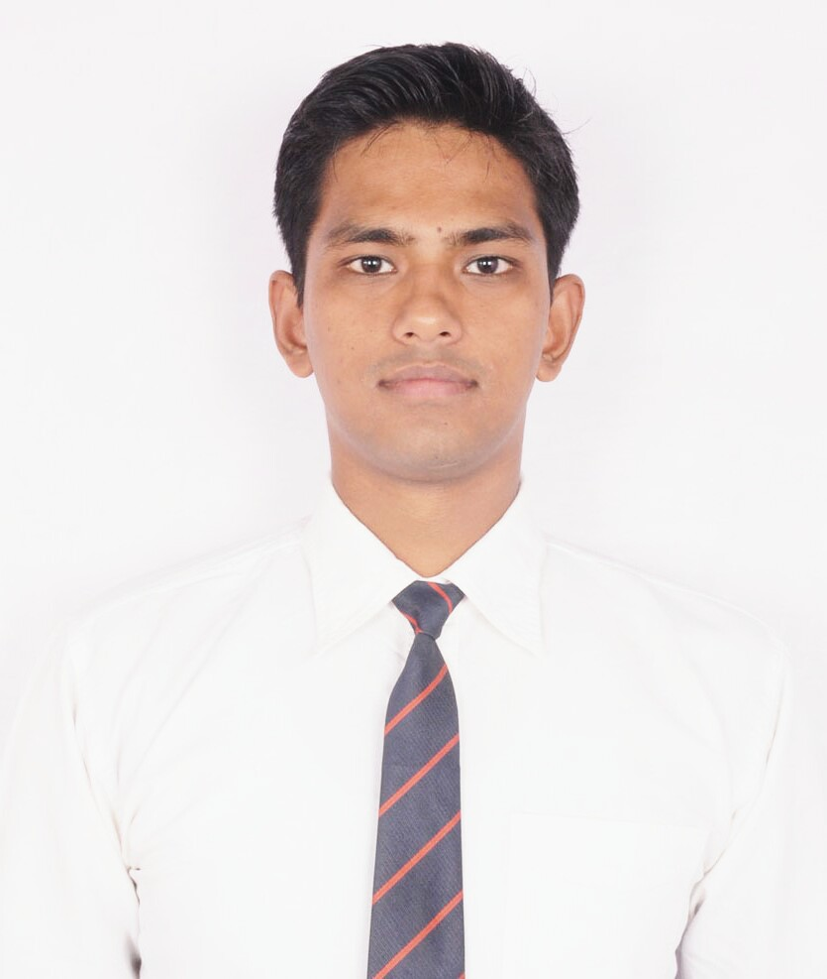
Email: shubhamb88@gmail.com
Contact no: +91-9560676218/ 8057865217
Address: Sector-17, Sukhrali, Gurgaon

JOB OBJECTIVE
Intend to build a career with leading corporate and professional environment, which will support me to explore myself and gain my potential.

Software Development  Web Designing  Requirement Gathering  Coding  Client Service | - MCA with 8 month experience in .net development with c# programming language.  - Presently associated with Nitso Technology Gurgaon.  - Developing application and delivering quality and performance.  - Joined course on software quality testing at Ducat Noida.  - APTECH (ADSE) holder with A- grade.
  SKILL SET
  PROFILE SNAPSHOT

TECHNICAL SKILLS

Coding Language: C#, ASP.net, ADO.net, HTML, CSS, Java Script

Database: SQL Server 2008

Awareness: Software Development Life Cycle, Testing e.g. Functionality T Testing, GUI Testing, Re-Testing, Regression Testing.

EMPLOYMENT DETAIL

Science April 4: Nitso Technology Gurgaon as Junior Software Developer.

Key Result Area:

- Accountable for developing .Net applications.

September 9-March 20: CITM Kashipur as Application Developer.
Key Result Area:

- Accountable for developing .Net windows applications (JMD Loans, Goraya Transport Management System).

ACADEMIC DETAILS

- M.C.A. from Apex Institute of Technology, Rampur affiliated with Dr. A.P.J. Abdul Kalam Technical
University in 2015; secured: 66%.
- B.C.A. from Shriram Institute of Management and Technology, Kashipur affiliated with Kumaun University in 2013; secured: 65%.
- 12th from Govind Ballabh Pant Inter Collage, Kashipur in 2009; secured: 48%.
- 10th from Saraswati Vidhya Mandir, Inter Collage, Rampur in 2007; secured: 64%.

LIVE PROJECTS
Project 1 Title | Guru Ji Album Window Application (Live Project).
Platform | .Net platform using SQL Server 2005 as backend
Role | Designed ,developed and tested.
Project 2 Title | JMD Loans Window Application (Live Project).
Platform | .Net platform using SQL Server 2005 as backend
Role | Designed ,developed and tested.
Project 3 Title | Goraya Transports Window Application (Live Project).
Platform | .Net platform using SQL Server 2005 as backend
Role | Designed ,developed and tested.

ACHIEVEMENTS & EXTRA CURRICULAR

- Given many more Seminars and Presentation related to computer and science during college.
- Good Exposure of technical analysis and leadership skills.
- Worked as Freelancer in many Projects during studies.

PERSONAL DETAILS

Nationality : Indian
Gender : Male
Date of Birth : 03rd July 1992
Status : Single
Permanent Address : Madhav Marg, Vaishali Colony,Kashipur (U.S.Nagar)
Languages Known : English, Hindi.
Hobbies : Playing Chess, Traveling and Surfing on Internet,

Declaration:

I here by declare that above information is correct to the best of my knowledge and belief.

Place: Delhi (Shubham Bisht)

